CST8101Computer Essentials
Lab 10

Install Windows 7, User creation, password management,
System information, Disk management,
Safe mode

Due Date: Wednesday, November 9, 2016
Marking:10

In this exercise, you will be exploring Windows 7.
Hint: Use Google for questions where the answer is not obvious from the Windows displayed.
Download windows 7 from the digital resources with the CD-key number
- Log in to your BB and go to digital resource
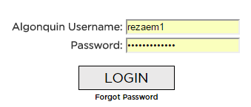

- click on Continue to Digital Resouce panel
- Choose Sotware and then Microsoft imagine premium
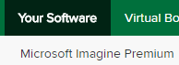
- Look for Windows 7 Professional
- Click on express checkout
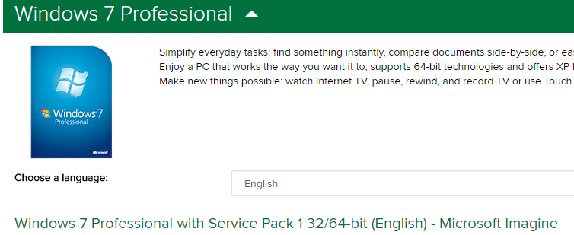

Note: If you got this message, click on Here.This page shows
You If you have downloaded the Windows 7 before.
In this case click on the link and start to download the file again and get the CD key number.
If this is the frist time you are download the file then keep following the instruction.

- Click on Start download
- In the download instruction page, click on the
Download SDM box first and then run the program. (default settings)
- Now click on the .sdx downolaod box and begin to download the Windows Progessional.(32/64 bit)
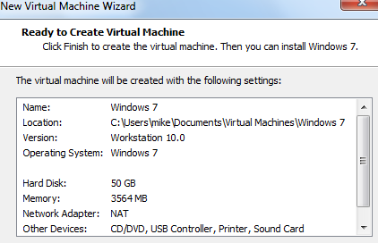

B-Create a virtual machine for windows 7
Follow previous intsruations( pervious labs) to create a virual
For Windows 7
- Use 4 GB ram and 50 GB hard disk space

In the Windows7 summary page in VMware, double-click on
the CD/DVD (IDE) device.

The Virtual Machine Settings window appears. Under Connection,
select the Use ISO image file: option and browse to the location of the
Windows 7 .ISO file) above Click OK.

C- Install Windows 7
In the Windows7 summary page in VMware, click on Power on this virtual
machine. Windows 7 begins to boot.

When the Install Windows window appears, select English as the language
to install, English (Canada) as the time and currency format, and US as the
keyboard or input method. Click Next.

The window refreshes. Click Install now. Setup begins
Next accept the licsence agreement

In the window that appears, select Custom (advanced) to install a
new copy of Windows 7.

In the Where Do You Want to Install Windows? Window that appears,
there should be one choice, Disk 0 Unallocated Space. Click Next.

Windows installation begins. This takes several minutes, after which the virtual
Windows installation reboots twice

When prompted, enter a username and computer name. For the username, use your
first initial and last name. For the computer name, use Virtual Win7. Click Next.

Set up a password and password hint for your account. Be sure to use a strong
password. Submit the password you used with your lab report. Click Next.

Input your Windows product key from Step II i) above. Click Next.

For the Help Protect Your Computer screen select install important updates only

Review your date and time settings and make any necessary changes. Select Next.

For the network, select Work network.

D-Update Windows 7

In your Windows 7 virtual machine, click the Start button and select
Control Panel →System and Security →Windows Update. Select
Check for updates.

Review the list of important updates by clicking on important updates
are available.

Select Install updates.
e) Accept any license terms agreements that appear. The updates are downloaded
and then installed.

Create a user account in Windows 7

- Go to Start, Control Panel, choose add or remove user account
- Click on what is a user account, read the contents andwrite down the three types of user accounts.
  - ____________administrator__________
  - ______________guest________
  - ________________standard______

- Click on Create a new account.
- Write down the two account types and a brief description:
  - ________standard—it can be use most software and change system setting that do not affect other users or the security of the computer.___________
  - _________administrator—it has complete acess to the computer and can make any desired changes .based on notification setting , administarators may be asked to provide their password or confirmation before making changes that affect other users. ______________
- In the Name the account and choose an account type box, create a user, call it TEST. Leave the standard user option as default and click on the create Account box.
  - Why is the Guest account off by default? (Remember to use Google)
___________To protect the computer from unauthorized users _________________________________________________
____________________________________________________________
- Log off as administrator and log in as the user TEST.
- Go back to user account and try to create a new user account.
  - Can you?Why not? ____no because I am not logged in as an administrator_______________________________________
Password Management (User TEST)

- Go to control panel and User Accounts and family Safety. Click on User Accounts, select Create a password for your account. Use the password Pass@12 and click on Create password.

- Try to change your account name?
- Can you? Why not?_______ no because I am not logged in as an administrator ______________________________

- Try to change your account type.
- Can you? Why not?_____ no because I am not logged in as an administrator ___________________________________

- Now choose Configure advanced user profile properties and click on Change Type box.You will see two types of Profiles: Roaming and Local Profile
- What is the Roamingprofile? (Google it)
A roaming user profile is a concept in the windows family of operating system that allows users with a computer joined to a windows server domain to log on to any computer on the same network and access their documents and have a consistent desktop experience,

- What is the Local Profile?
_ A local profile is a profile created with a log –in and password and issued to an employee. The person then logs on to the system and makes some settings changes to that profile. These settings could include downloading certain applications, changing the desktop settings, browser settings, etc.
System Information
- Log off as user TEST and Log in as the Administrator
- Click on Start, Control panel, System and security, choose System.
- Using the Windows 7 Snipping Tool, take a screenshot of your View basic information about your computer and insert it here:
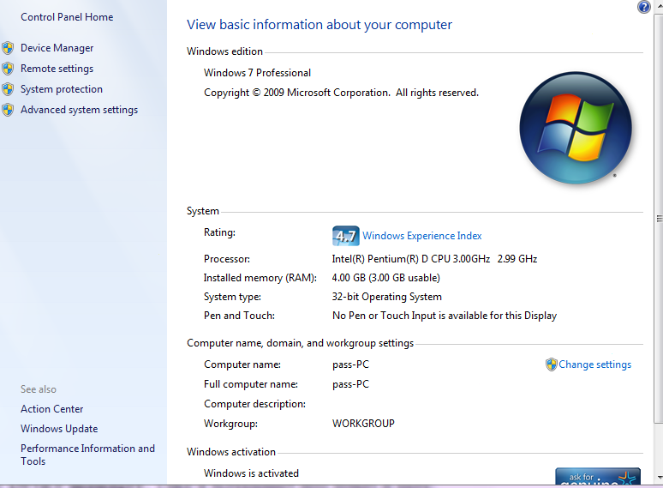

  - Computer name:_Aman__________________

  - Full computer name:__Aman_______________

  - Workgroup:___WORKGROUP__________________

- In the View basic information about your computer page, click on Advanced System Settings.

- In the System Properties choose the Computer Name tab, click on the Change box.
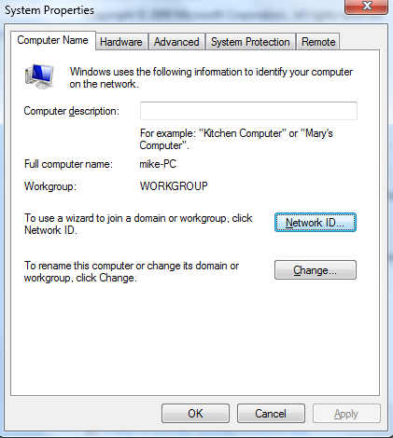

  - What is a Workgroup?( Google it) _ a workgroup is a collection of computers on a local area network (LAN) that share common resources and responsibilities___________________________
  - What is a Domain? (Google it) __A group of computers and devices on a network that are administered as a unit with common rules and procedures. Within the Internet, domains are defined by the IP address. All devices sharing a common part of the IP address are said to be in the same domain.____

  - Can you change your Computer name? yes

  - Can you change your Full computer name? (Google it) _YES________________

  - What is the difference between Computer name and Full computer name? (Google it) ___full name is combined with the domain name but the computer name____________________________________
- In the System Properties page, click on theAdvanced tab, thenPerformance pane, clickon Settings and then choose the Advanced tab again. You will see the Performance Options windows
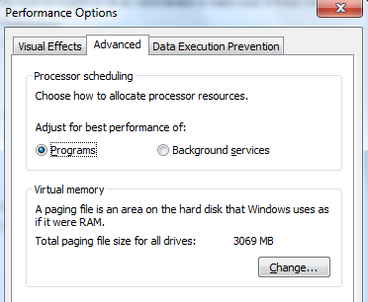
My computer

- What is the size of your virtual memory? _4095____________________

- What is virtual memory? _ virtual memory is a memory management technique that is implemented using both hardware and software. _______________________________
____________________________________________________________

- Go back to the System Properties page.
- In the System Properties page,under theAdvanced tab, on the Startup and recovery pane, click on Settings.
- From the Write Debugging Information pane:
  - What is the Kernel memory dump? _ A Kernel Memory Dump contains all the memory in use by the kernel at the time of the crash._____________________________
  - What is the name of the Dump file? _ %SystemRoot%\MEMORY.DMP
- Click OK to get out.
User Policy (Administrative Tools)
- Go to Start, Control Panel, click on the System and Security and then on Administrative Tools
- Click on Computer Management and choose Local Users and Groups and then Users:
- Right click on the user TESTand click on Properties.
- In the TEST properties window, uncheck the Password never expir esoption.
- Put a check mark in User must change password at next logonand click Apply.
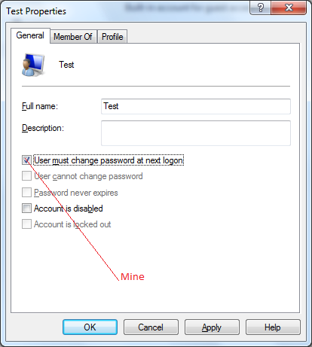

  - Why Account is locked out is gray (unavailable)? Google it.
__for security reasons whether the Administartor is enable or disable________________________________________________
- Now, click on the Member Of tab
  - To which groups he/she (TEST) belongs to? __USERS__________________________
- Click on AddAdvanced and Find Now button. You will see all default groups in Windows 7.
- Under Search results, look forthe power user group.Highlight the power users group and click OK, OK. Now user TESTis the member of the Power Users group.
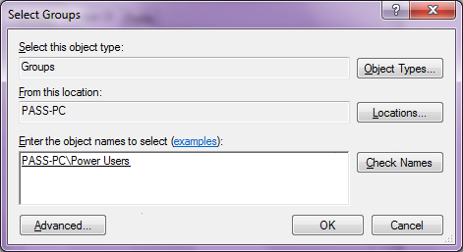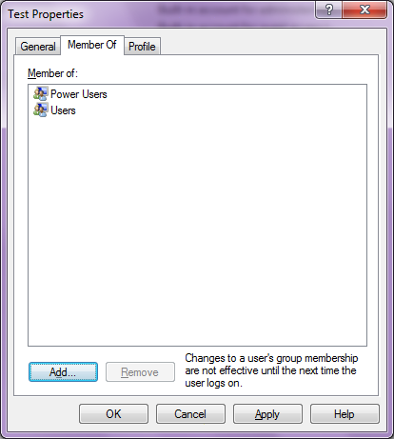

Testing the user’s rights and permissions

- Log off as administrator and log in as the user TESTagain
- What message/warning did you get?_the user’s password must be change before logging on the first time_____________
- Click OK and change the password to “pass” (lower case).
- As a member of the power user go back to Control Panel, System and Security, Administrative Tools and choose Computer management.
  - Did you have access? __no___________
  - Why not? ____because we have to log in as a administrator
  - What is the difference between the user rights and the user Permissions? (Google it)
_ User rights generally refer to logon capabilities: who can logon interactively, as a batch job, as a service, over the network, over Terminal Services, etc.
Permissions relate to the capability of accessing an object, such as a file, a registry entry, a service, a printer, a share, etc
Disk management

- Log off as the user TEST and log in as Administrator again
- Go back to Control Panel and Administrative Tools.
- Click on Computer Management and choose Disk Management
- How many physical hard drives do you have? _1_________________
- What is the size of your hard drive? ____50 GB______________________
- How many partitions does your hard drive have? __One_____________
- What is the file system for drive C (Disk 0)? NTFS__________________

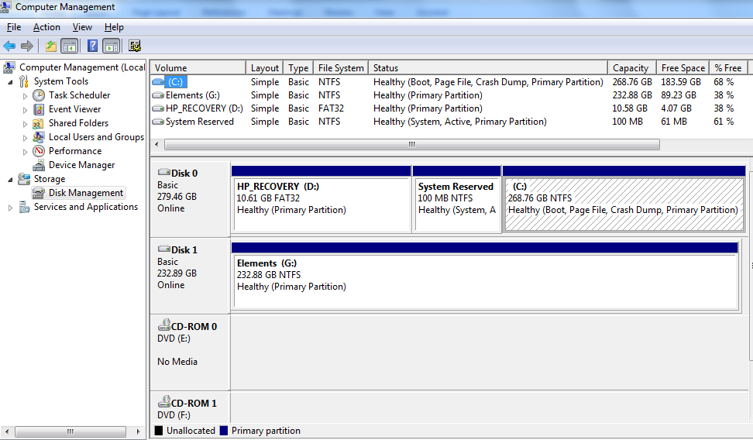

Getting in the Safe Mode (troubleshooting tool)

- Go to Start and in the search box type “msconfig” and press enter.
- In the msconfig window, choose the Boot tab.
- Under Boot options pane, put a check mark on the safe boot box and click ok.
- Select RESTART when prompted.
NOTE: Always save any open documents before rebooting your computer.
- What is the difference between the Safe Mode and Normal Mode?
__ Normal mode (which is not an exact technical term) is the default operation mode of a computer operating system, while safe mode is a diagnostic mode for troubleshooting issues in a computer system.
- Make sure you go back to msconfig and uncheck the box for safe mode and reboot your computer to get back to Normal mode.

